User Requirements Document

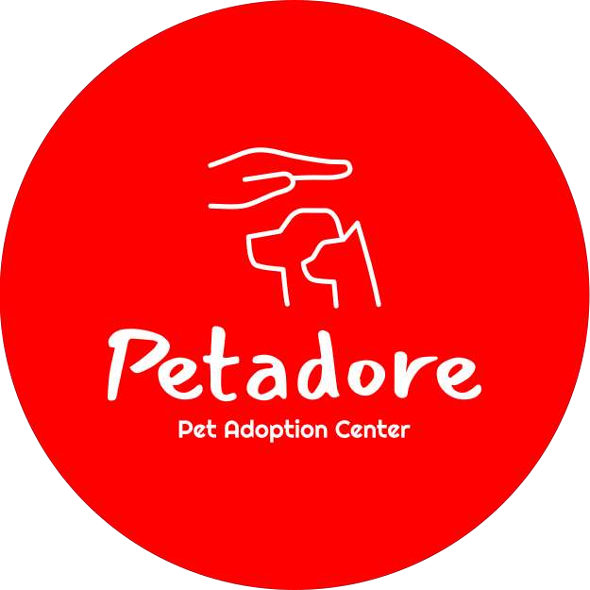

~ Ziyadatan Imad Aqil Mardi

Date: 16-02-2023

Version: 2.0

# Table of Contents

1. User Requirements ......................................................................................................................... 1
   1. Functional Requirements ........................................................................................................ 1

Desktop Application ........................................................................................................................ 1

Web Application .............................................................................................................................. 1

* 1. Non-Functional Requirements ................................................................................................ 1

1. Use Case .......................................................................................................................................... 2
   1. Uses Cases ............................................................................................................................... 2

UC-01: User add new animals ................................................................................................. 2

UC-02: User remove existing animals ..................................................................................... 2

UC-03: User edit existing animals ........................................................................................... 2

UC-04: User add new shelters ................................................................................................. 3

UC-05: User remove existing shelters ..................................................................................... 3

UC-06: User edit existing shelters ........................................................................................... 3

UC-07: User view animal information ..................................................................................... 3

UC-08: User view shelter information .................................................................................... 4

UC-09: User view shelter information .................................................................................... 4

UC-10: User view shelter information .................................................................................... 4

UC-11: Client logs in to website .............................................................................................. 5

UC-12: Client searches for specific animals ............................................................................ 5

UC-13: Client view animal details ........................................................................................... 5

UC-14: Client searches for specific shelters ............................................................................ 5

UC-15: Client view shelter details ........................................................................................... 6

UC-16: User remove existing shelters ..................................................................................... 6

UC-17: User edit existing shelters ........................................................................................... 6

* 1. Wireframe ..............................................................................................................................7

Desktop Application ...................................................................................................................... 7

Website Application ...................................................................................................................... 7

# User Requirements

1.1. Functional Requirements

The desktop application will be mainly used to insert new information, look for this information and edit this information.

|  |  |
| --- | --- |
| Desktop Application | MoSCoW |
| FR-01: User can add new animals | Must |
| FR-02: User can remove existing animals | Must |
| FR-03: User can edit animal information | Could |
| FR-04: User can add new shelters | Must |
| FR-05: User can remove existing shelters | Must |
| FR-06: User can edit shelter information | Should |
| FR-07: User can view animals | Must |
| FR-08: User can view shelters | Must |
| FR-09: User can view Clients | Must |
| FR-10: User can view Client adoption orders | Must |

|  |  |
| --- | --- |
| Web Application | MoSCoW |
| FR-11: User can Register an account to the website | Should |
| FR-12: User/Client can log in to the website | Should |
| FR-13: User/Client can search for specific animals | Should |
| FR-14: User/Client can view animal details | Must |
| FR-15: User/Client can search for specific shelters | Should |
| FR-16: User /Client can view shelter details | Must |
| FR-17: User/Client can leave a review for the shelter | Could |
| FR-18: User/Client can request to adopt animal | Must |

1.2. Non-Functional Requirements

1. NFR-01: Maintainable and extendable. Proper OO principles must be applied to ensure good maintainability and extensibility of the code base.
2. NFR-02: Bug free system. Appropriate testing techniques must be used when implementing the system to ensure proper functioning.
3. NFR-03: Secure software. Only authorized people may make use of the system and can only access data for which they are authorized. Passwords and user input must also be managed appropriately.

# Use Case / Wireframe

2.1. Uses Cases

Desktop Use Cases

* UC-01: User add new animals

**Requirements**: FR-01

**Actor**: Admin

**Pre-Condition**:-

**Trigger**: Admin requests to add animals

**Main Success Scenario**:

* + 1. System requests animals information
    2. Actor fills in required parameter
    3. Animal added
    4. End Use Case

**2a. Extensions**: Information does not fit the required parameter

* + 1. System display error message
    2. End Use Case

* UC-02: User remove existing animals

**Requirements**: FR-02

**Actor**: Admin

**Pre-Condition**: FR-01, must have at least 1 animal in the database **Trigger**: Admin requests to remove animals

**Main Success Scenario**:

* + 1. Actor selects the desired animal to be deleted
    2. System shows confirmation message
    3. Animal removed
    4. End Use Case

* UC-03: User edit existing animals

**Requirements**: FR-03

**Actor**: Admin

**Pre-Condition**: FR-01, must have at least 1 animal in the database **Trigger**: Admin requests to edit animal information

**Main Success Scenario**:

* + 1. Actor selects desired animal to be edited
    2. Actor fills in required parameter
    3. Animal edited
    4. End Use Case

**2a. Extensions**: Information does not fit the required parameter

* + 1. System display error message
    2. End Use Case
* UC-04: User add new shelters

**Requirements**: FR-04

**Actor**: Admin

**Pre-Condition**:-

**Trigger**: Admin requests to add shelters

**Main Success Scenario**:

* + 1. System requests shelters information
    2. Actor fills in required parameter
    3. Shelter added
    4. End Use Case

**2a. Extensions**: Information does not fit the required parameter

* + 1. System display error message
    2. End Use Case

* UC-05: User remove existing shelters

**Requirements**: FR-05

**Actor**: Admin

**Pre-Condition**: FR-04, must have at least 1 shelter in the database **Trigger**: Admin requests to remove animals

**Main Success Scenario**:

* + 1. Actor selects desired shelter to be removed
    2. System shows confirmation message
    3. Shelter removed
    4. End Use Case
* UC-06: User edit existing shelters

**Requirements**: FR-06

**Actor**: Admin

**Pre-Condition**: FR-04, must have at least 1 shelter in the database **Trigger**: Admin requests to edit animal information

**Main Success Scenario**:

* + 1. Actor selects desired shelter to be edited
    2. Actor fills in required parameter
    3. Shelter edited
    4. End Use Case

**Extensions**: Information does not fit the required parameter

* + 1. System display error message
    2. End Use Case

* UC-07: User view animal information

**Requirements**: FR-07

**Actor**: Admin

**Pre-Condition**: FR-01, must have at least 1 animal in the database

**Trigger**: Admin requests to view animal

**Main Success Scenario**:

* + 1. Actor opens view animals tab
    2. System shows animals
    3. End Use Case
* UC-08: User view shelter information

**Requirements**: FR-08

**Actor**: Admin

**Pre-Condition**: FR-04, must be at least 1 shelter in the database **Trigger**: Admin requests to view shelter

**Main Success Scenario**:

1. Admin requests to view shelters
2. System shows shelters
3. End Use Case

* UC-09: User view client information

**Requirements**: FR-09

**Actor**: Admin

**Pre-Condition**: must have at least 1 client in the database **Trigger**: Actor requests to view clients

**Main Success Scenario**:

1. Admin requests to view clients
2. System shows clients
3. End Use Case

* UC-10: User view Clients orders

**Requirements**: FR-09

**Actor**: Admin

**Pre-Condition**: FR-17

**Trigger**: Admin requests to view client orders

**Main Success Scenario**:

1. Admin requests to view client’s order
2. System shows client’s order
3. End Use Case

**Extensions**: clients has no orders

1. Show Message “Client has no orders”
2. End use case

* UC-11: Client registers in to website

**Requirements**: FR-11

**Actor**: Client

**Pre-Condition**: client have email, username and password

**Trigger**: Client requests to Register to website

**Main Success Scenario**:

* + 1. System requests user information
    2. Actor fills in required parameter
    3. User is logged in
    4. End Use Case

**Extensions**: Information does not fit the required parameter

* + 1. System display error message
    2. End Use Case
* UC-12: Client logs in to website

**Requirements**: FR-11

**Actor**: Client

**Pre-Condition**: Client must be registered, client have username and password **Trigger**: Client requests to log in to website

**Main Success Scenario**:

1. System requests user information
2. Actor fills in required parameter
3. User is logged in
4. End Use Case

**Extensions**: Information does not fit the required parameter

1. System display error message
2. End Use Case

* UC-13: Client searches for specific animals

**Requirements**: FR-12

**Actor**: Client

**Pre-Condition**: FR-11

**Trigger**: Client searches for specific animals

**Main Success Scenario**:

* + 1. Client uses terms to filter animals
    2. Website shows animals that fits the specified category
    3. End Use Case

**Extensions**: Information does not fit the required parameter

* + 1. Website shows nothing
    2. End Use Case

* UC-14: Client view animal details

**Requirements**: FR-13

**Actor**: Admin

**Pre-Condition**: FR-11

**Trigger**: Client requests to view animal’s details

**Main Success Scenario**:

* + 1. Client requests to view animal’s details
    2. System shows animal details
    3. End Use Case

**Extensions**: -

* UC-15: Client searches for specific shelters

**Requirements**: FR-14

**Actor**: Client

**Pre-Condition**: FR-11

**Trigger**: Client searches for specific shelters

**Main Success Scenario**:

* + 1. Client uses terms to filter Shelters
    2. Website shows shelters that fits the specified category
    3. End Use Case

**Extensions**: Information does not fit the required parameter

* + 1. System display error message
    2. End Use Case

* UC-16: Client view shelter details

**Requirements**: FR-15

**Actor**: Admin

**Pre-Condition**: FR-11

**Trigger**: Client requests to view shelter’s details

**Main Success Scenario**:

* + 1. Client requests to view shelter’s details
    2. System shows shelter details
    3. End Use Case

**Extensions**: -

* UC-17: User remove existing shelters

**Requirements**: FR-16

**Actor**: Client

**Pre-Condition**: FR-11

**Trigger**: Client requests to leave a review for the shelter

**Main Success Scenario**:

* + 1. System requests review
    2. Actor fills in required parameter
    3. Review sent
    4. End Use Case

**Extensions**: Information does not fit the required parameter

* + 1. System display error message
    2. End Use Case

* UC-18: User edit existing shelters

**Requirements**: FR-17

**Actor**: Client

**Pre-Condition**: FR-11

**Trigger**: Client requests to adopt animal

**Main Success Scenario**:

* + 1. Actor requests to adopt animal
    2. Request sent to the admin page
    3. End Use Case

2.2. Wireframe

## Desktop Application

*Figure 1: Home/Adoption Requests Page*

*Figure 2: Animal Page*

*Figure 3: Shelter Page*

*Figure 4: Client Page*

## Website Application

*Figure 1: Home/Adoption Requests Page*

*Figure 2: Animal Page*

*Figure 3: Shelter Page*

*Figure 4: Client Page*